**TSH - Dried Blood Spot (DBS) Test**

TSH (Thyroid-Stimulating Hormone) testing is essential for diagnosing and monitoring thyroid disorders, such as hypothyroidism and hyperthyroidism. It evaluates thyroid function by measuring how much TSH the pituitary gland releases in response to the body’s need for thyroid hormones. This document details the comparison between Thyroid-Stimulating Hormone (TSH) testing using the Whatman 903 Dried Blood Spot (DBS) samples and traditional venous draw for testing at IHDLab.

Testing Collection and Methods Overview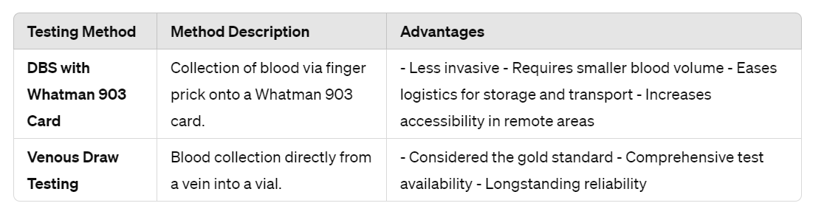

Data on Sensitivity and Specificity - Correlation: Upholding our high standards for precision, the validation study reported a correlation of 99.35% between DBS on Whatman 903 cards and venipuncture, reflecting our commitment to accuracy in every test conducted.

Clinical Relevance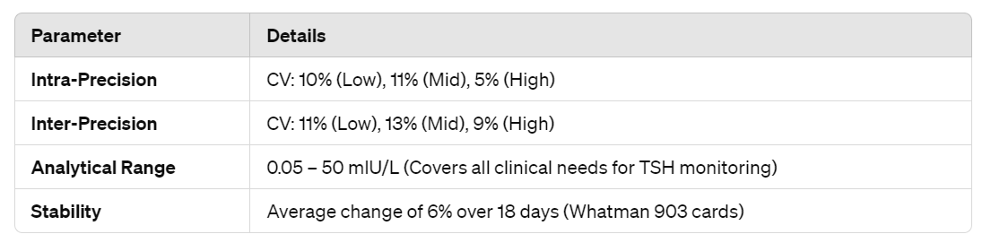

Conclusion: DBS testing on Whatman 903 cards embodies our mission by providing a practical, reliable, and accessible alternative to venous draw to empower every person with access to accurate and actionable clinical testing when and where it matters most.