


User Guide
Partner Admin Portal

Table of Contents

Overview 3
First-time Login 3
Login 5
Orders Dashboard 7
Kit Orders 7
Lab Orders 13
Patients Dashboard 19
API Keys Dashboard 25
Create API Key 27
Edit/ Revoke API Key Permissions 29

Overview
The Labflow partner admin portal provides a platform for partners to view patients and orders created in their organization. Through this portal, partner admins can create new orders, track the status of the existing orders, and create API keys required for the organization. This guide provides step-by-step instructions on how to use the platform.

First-time Login
Once the Super admin of the Labflow platform adds a partner admin through the admin panel, the partner admin will receive an email notification to set up the account.

- Open the email received from Labflow.

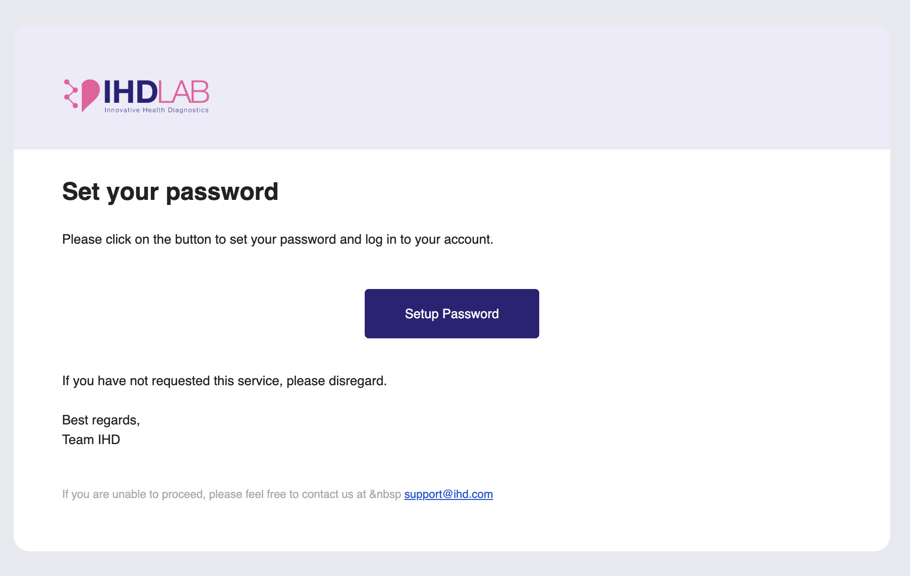

- Click on the ‘Setup Password’ button. This will redirect you to the ‘Password setup’ page.

- Enter a new password that includes a combination of upper and lower-case letters, numbers, and special characters
  - Password- Create a strong password and enter it in the ‘Password’ field
  - Confirm Password- Re-enter the password in the ‘Confirm Password’ field to ensure accuracy
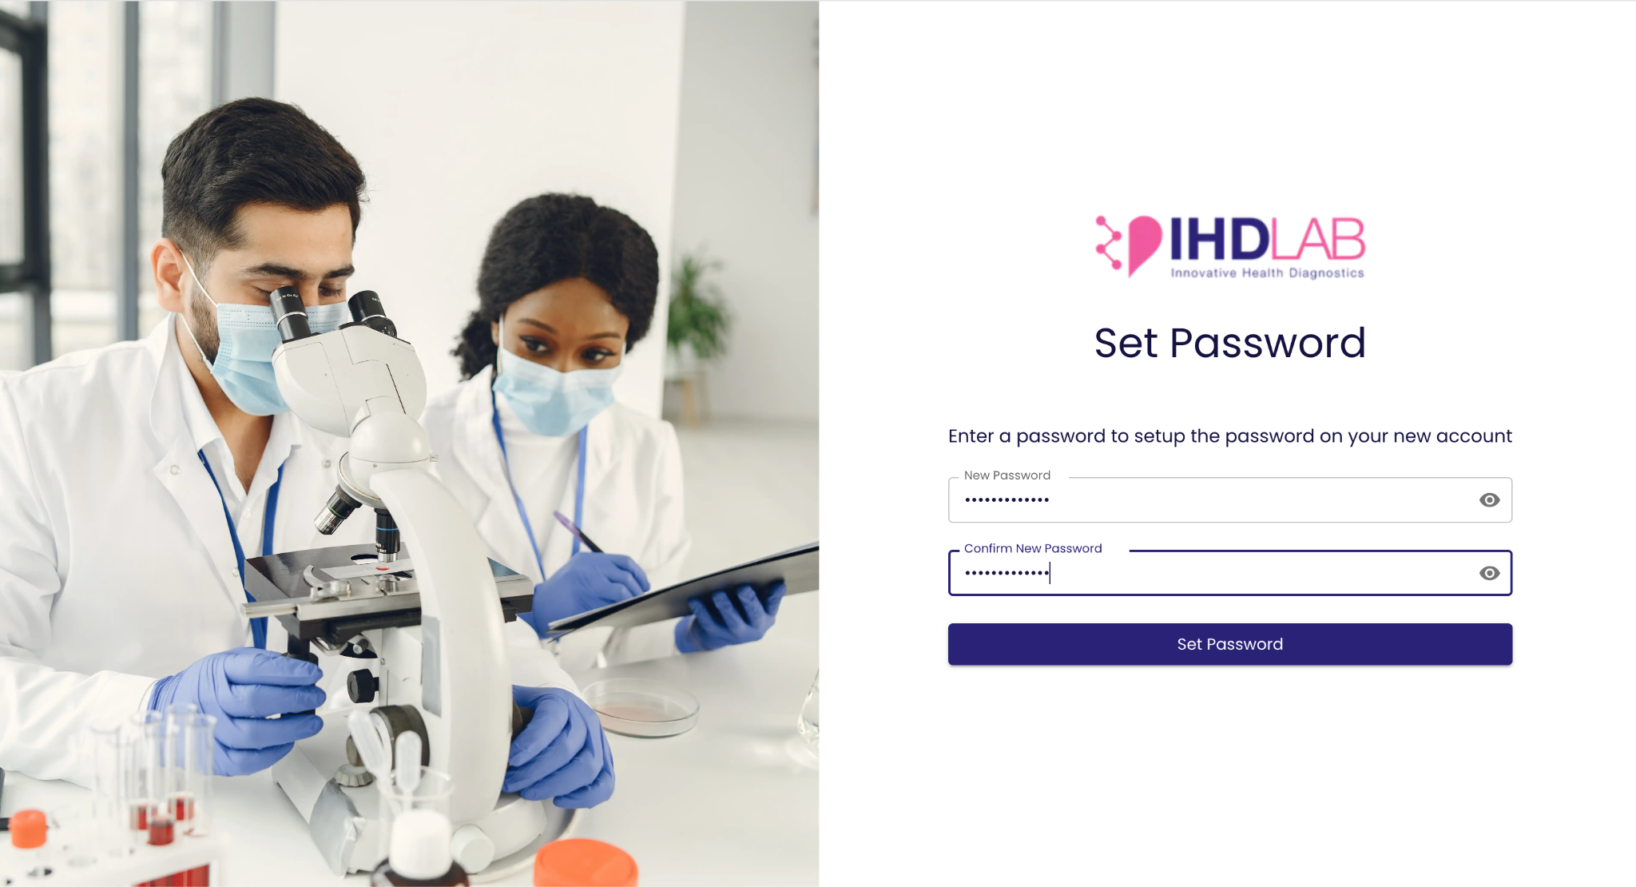

- Click ‘Set Password’ to set your password and start using your account.

- Once the password is successfully set, you will be prompted with a success message and click on the ‘Back to Login’ link to be redirected to the login page.
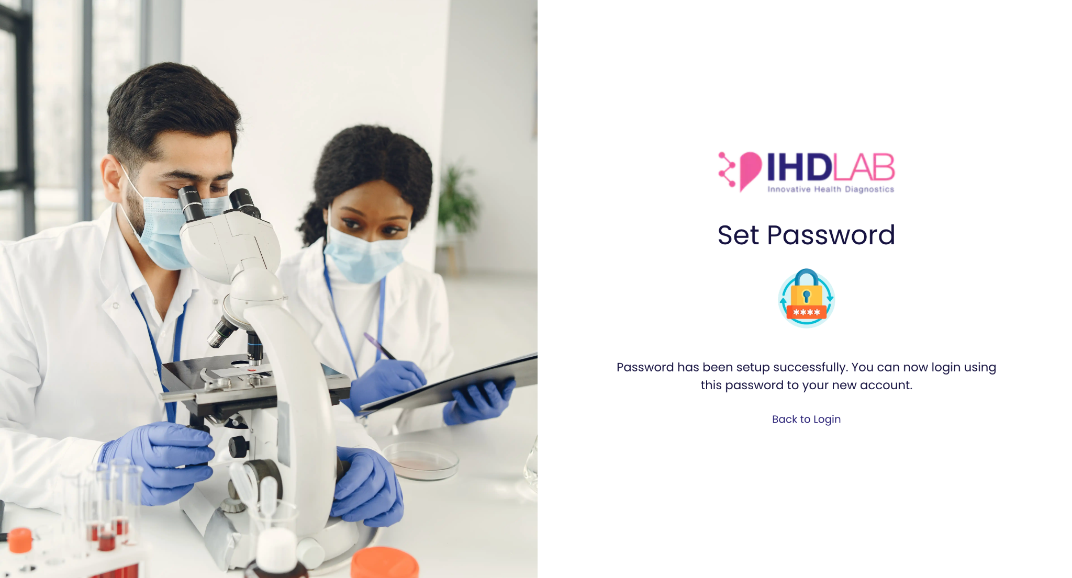

Login
- Access the Login URL.

- Enter your credentials and click the ‘Login’ button.
  - Email- Enter your email address in the ‘Email’ field
  - Password- Enter your password in the ‘Password’ field
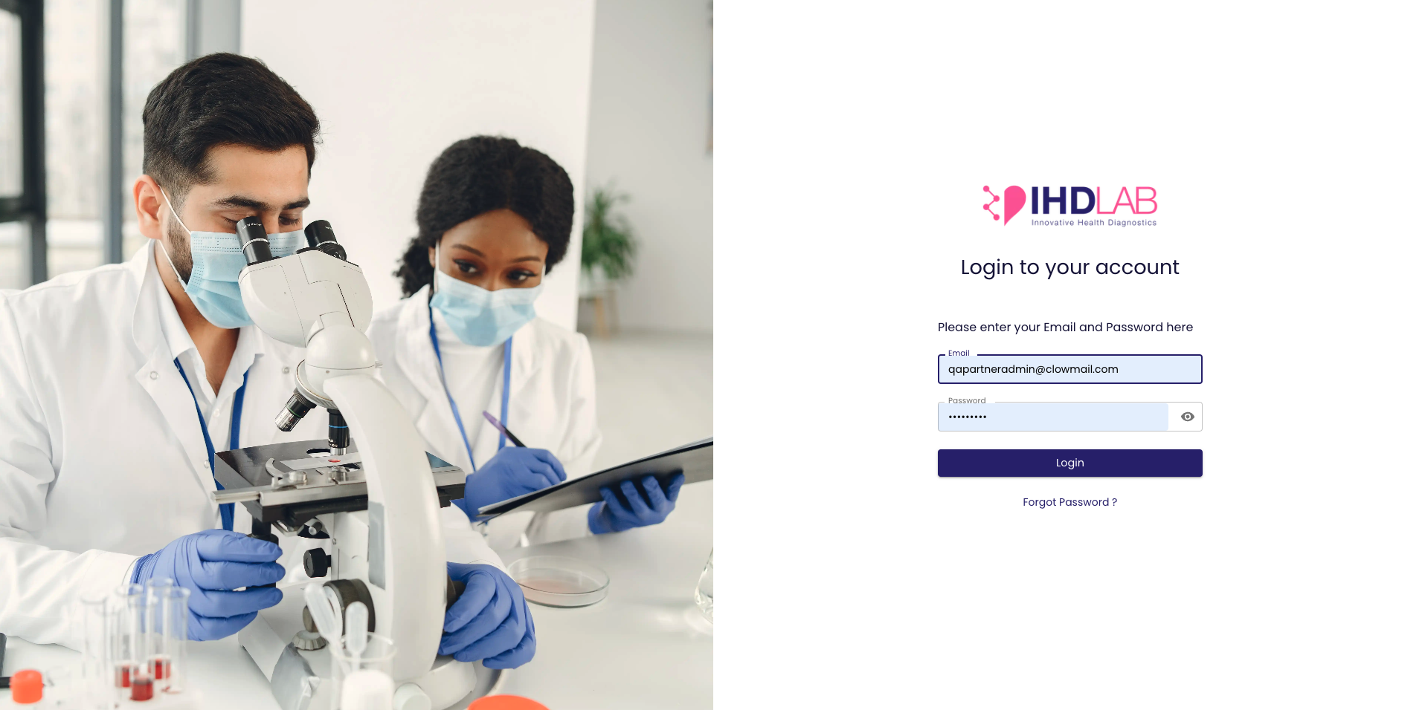

- Upon successful login, you will be redirected to the home page. The home page includes the following options in the hamburger menu:
  - Orders
  - Patients
  - API Keys

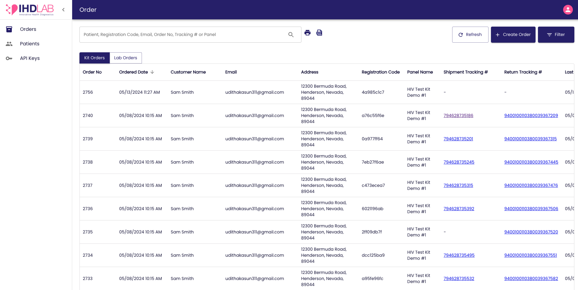

Orders Dashboard
All the kits that have been purchased and registered from your organization will be displayed in the ‘Order’ dashboard. You can click on the toggle available in the left corner of the dashboard to switch between:
- Kit Orders
- Lab Orders

Kit Orders
- This includes the kits purchased from the organization. The following kit order details will be available:
  - Order number
  - Ordered date/ time
  - Customer name
  - Email
  - Address
  - Registration code
  - Panel name
  - Shipment tracking number
  - Return tracking number
  - Last updated date/ time
  - Status

- You can use the following features to interact with the dashboard:
  - Search- Locate the search bar on top of the dashboard. Click inside the search bar and type in the keyword or phrase you want to search for. Press Enter or click the Search icon. You can search by the Customer Name, registration code, email, order number, tracking numbers, and panel name. The dashboard will update to display entries that match your search criteria.
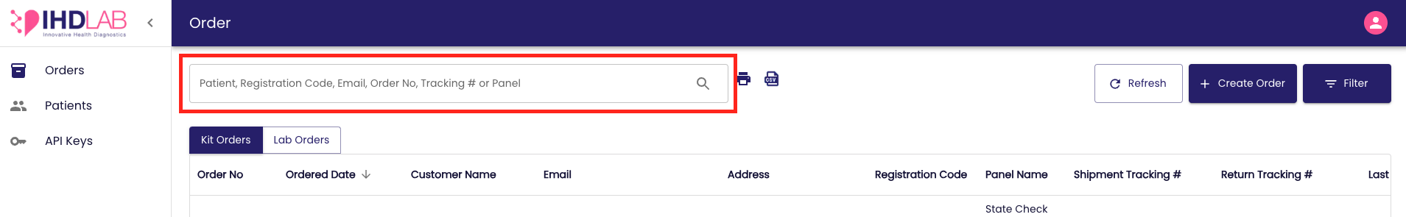

  - Sort- Find the Sort options in the table header represented by an arrow. Click on the column header you wish to sort by and on-click it will sort in ascending order, and clicking again will sort in descending order.
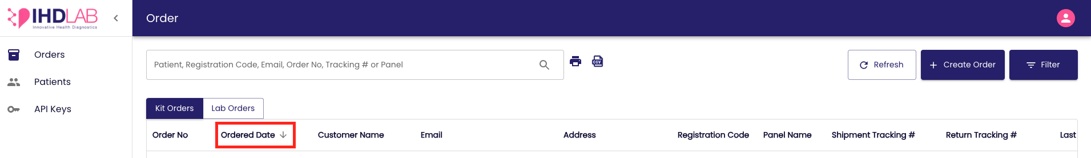
  - Filter- Locate the Filter option on the top right corner of the dashboard.
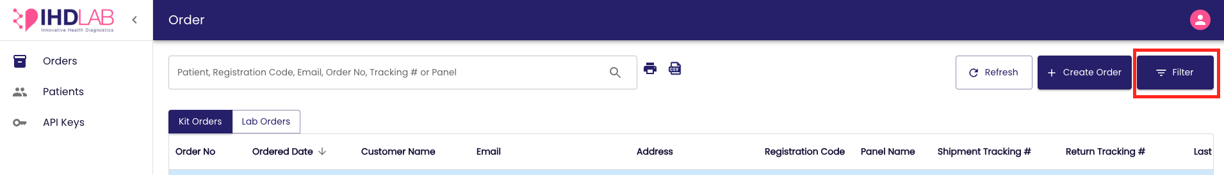

On-click the filter panel will be prompted and you can select the filter criteria from the option. Upon selection, click on the ‘Apply’ button and the dashboard will update to show entries that match the chosen criteria. To clear filters, click on the ‘Clear Filters’ button, and to set the default filter selection, click on the ‘Set Default’ button.

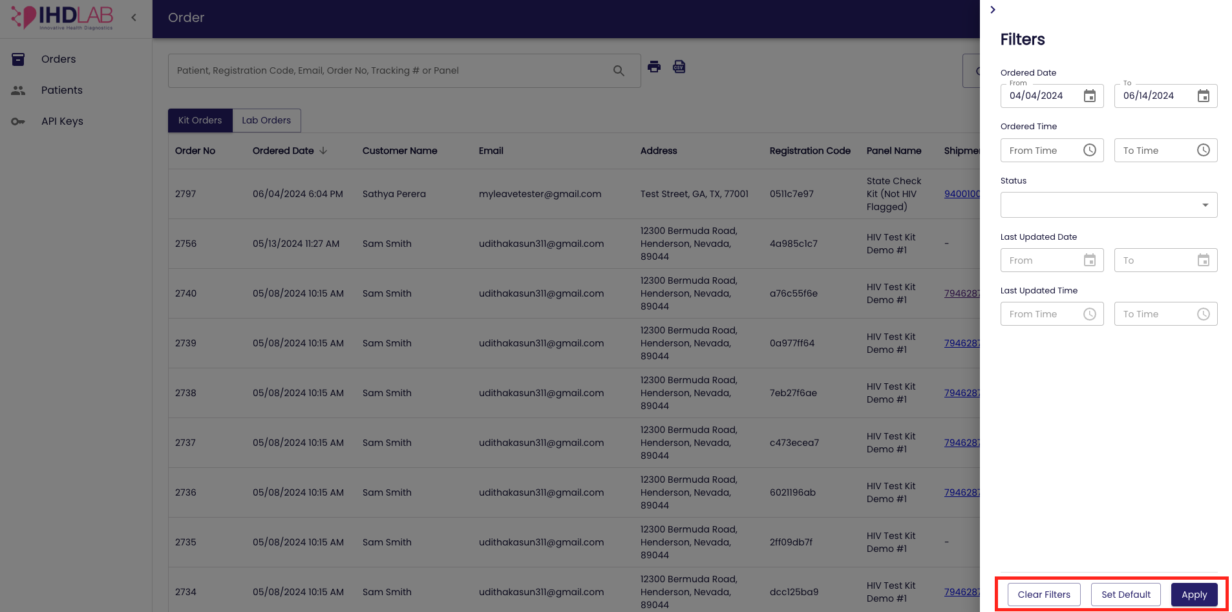

  - Print- Locate the Print icon next to the search bar. Ensure the dashboard is displaying the data you want to print. You can use search, sort, and filter options to refine the displayed entries as needed. Click on the ‘Print’ icon.
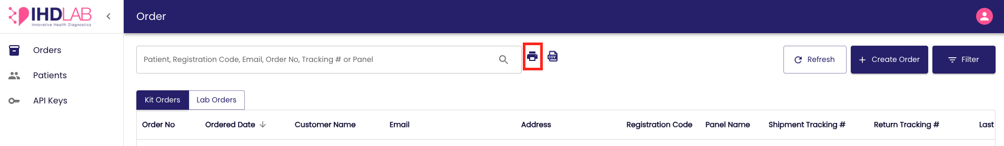

A print preview window will open, displaying the formatted data ready for printing. Click ‘Print’ in the preview window to send the document to your printer.

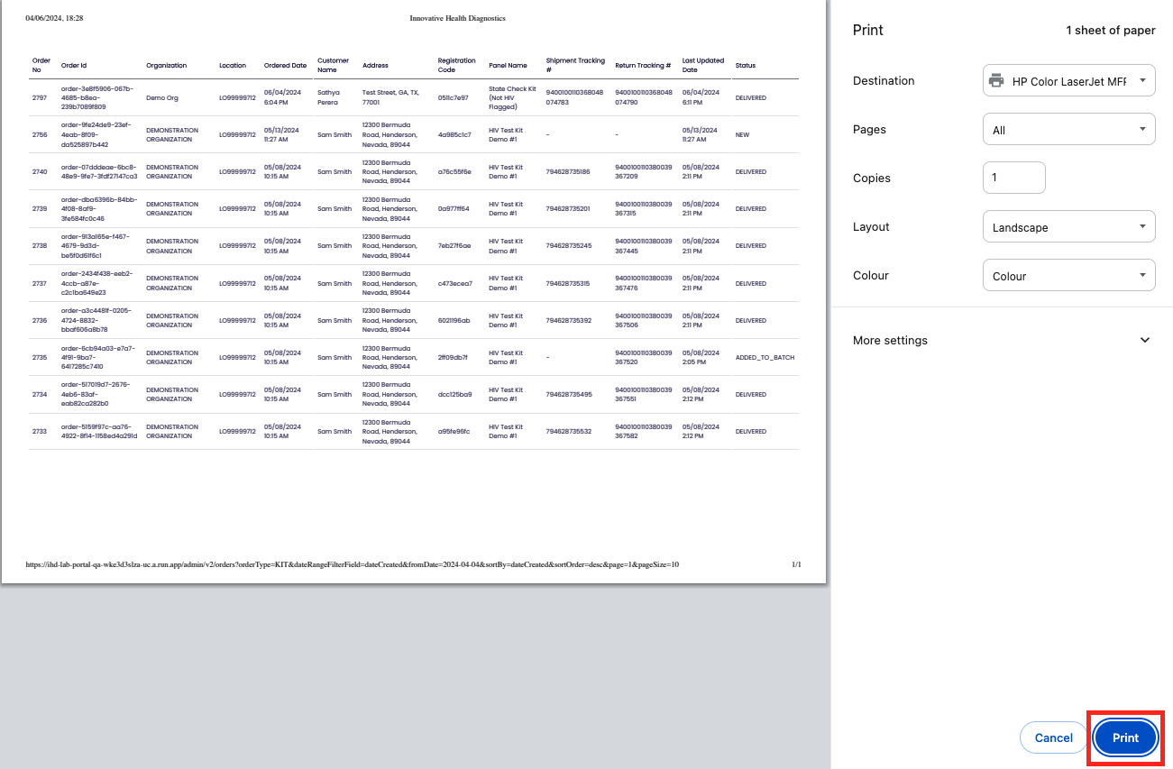

  - Export CSV- Locate the CSV icon next to the print icon. Ensure the dashboard is displaying the data you want to export. Use search, sort, and filter options to refine the entries as needed. Click on the ‘Export CSV’ icon and the CSV file will be downloaded.
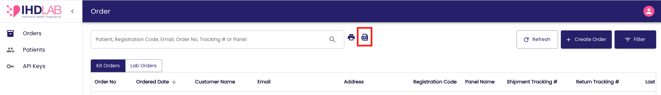

  - Refresh- Locate the Refresh button next to the Filter button in the top right corner. Click on the ‘Refresh’ button. The dashboard will reload, fetching the latest data. You may see a brief loading indicator while the data is being refreshed.
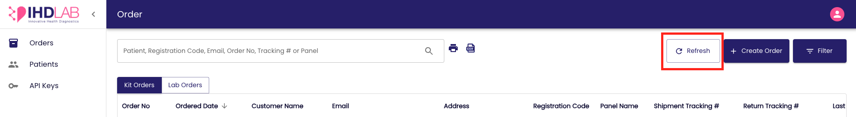

- You can view the order detail page by clicking on the entry. This can be done by clicking anywhere on the entry row. Identify the entry you want to view in detail. Click on the Order entry. You will be redirected to the ‘Order Detail’ Page of the selected entry.

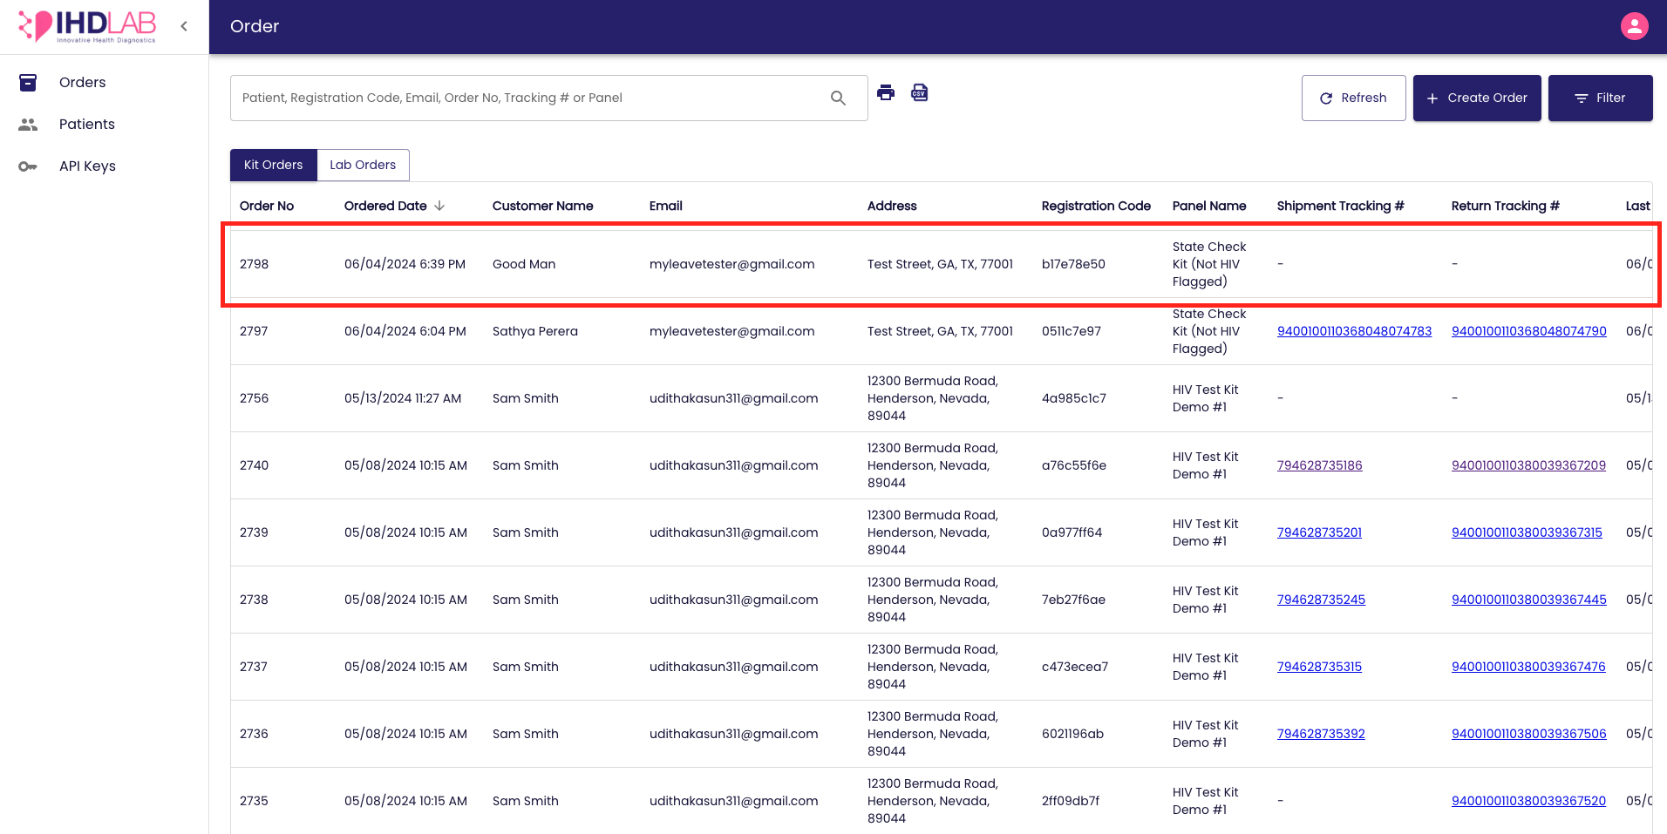

The Detail Page will provide comprehensive information about:
- Kit Order
- Customer Details
- Mailing Details
- Billing Details
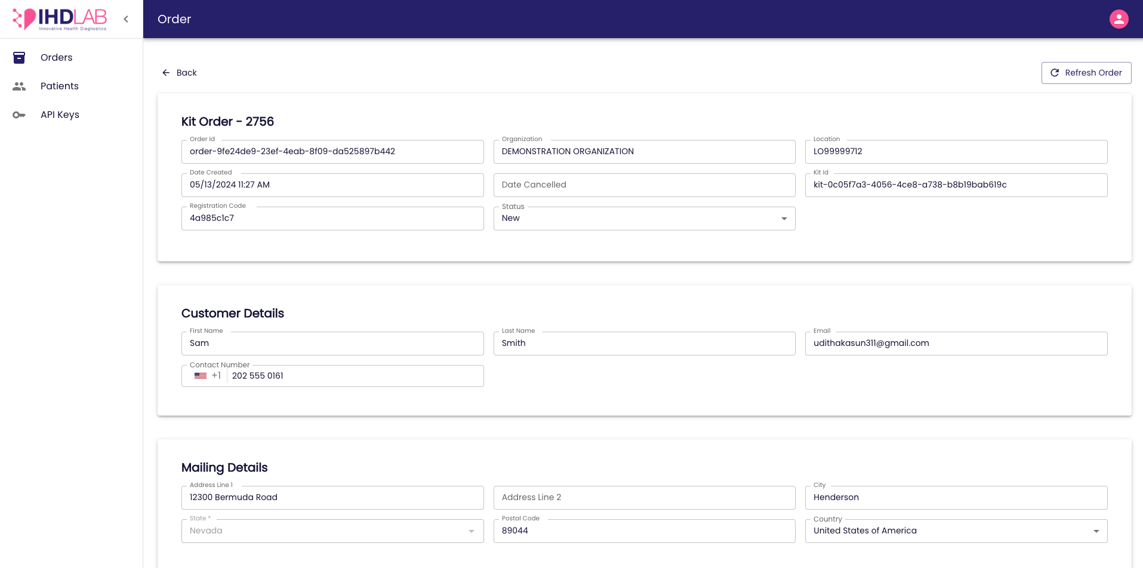

You can click on the ‘Refresh Order’ button on the top-right corner of the Order detail page to fetch the latest data. You may see a brief loading indicator while the data is being refreshed.

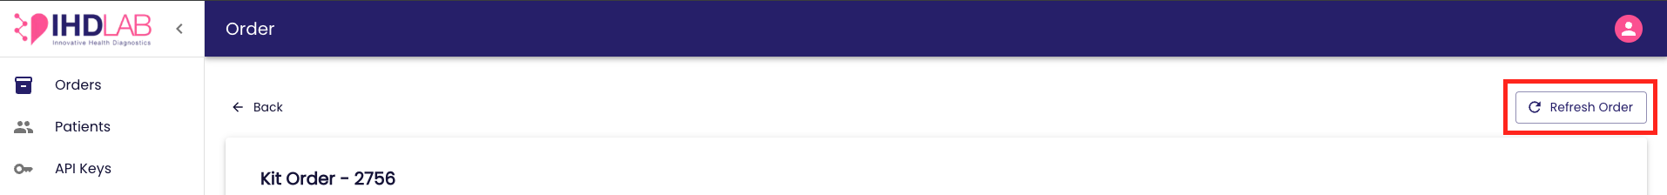

You can click the ‘Back’ button on the top-left corner of the Order detail page to go back to the ‘Order’ dashboard.

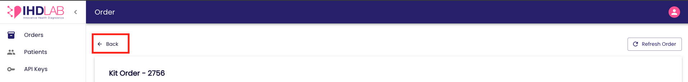

Lab Orders

- This includes the kits that patients register for test results
- Order number
- Ordered date/ time
- Patient name
- Email
- Registration code
- Panel name
- Shipment tracking number
- Return tracking number
- Last updated date/ time
- Status
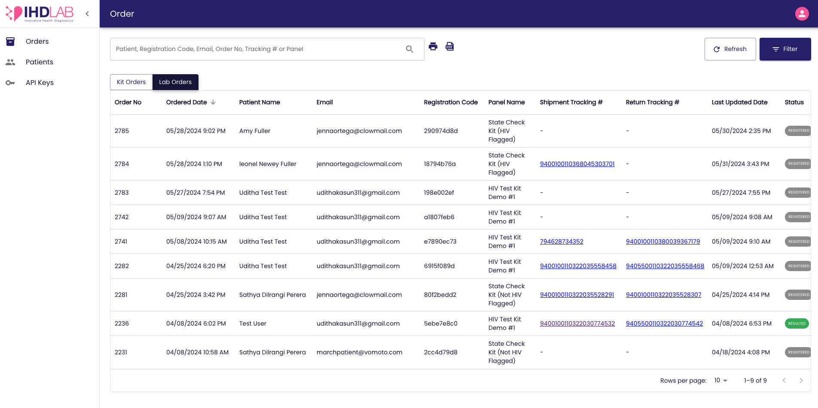

- You can use the following features to interact with the dashboard:
  - Search- Locate the search bar on top of the dashboard. Click inside the search bar and type in the keyword or phrase you want to search for. Press Enter or click the Search icon. You can search by the patient name, registration code, email, order number, tracking numbers, and panel name. The dashboard will update to display entries that match your search criteria.
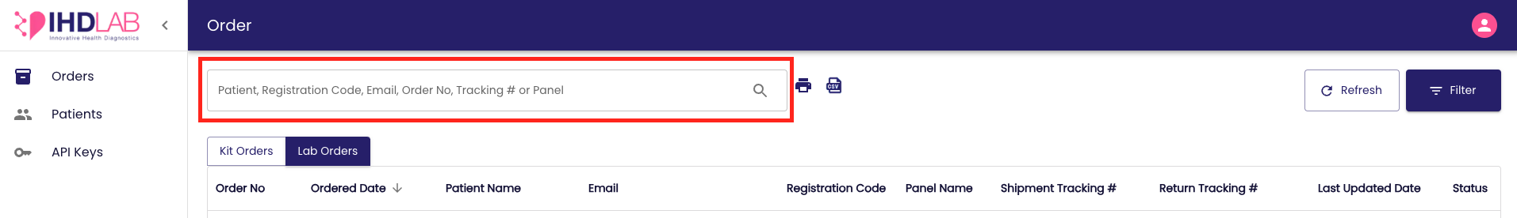

  - Sort- Find the Sort options in the table header represented by an arrow. Click on the column header you wish to sort by and on-click it will sort in ascending order, and clicking again will sort in descending order.

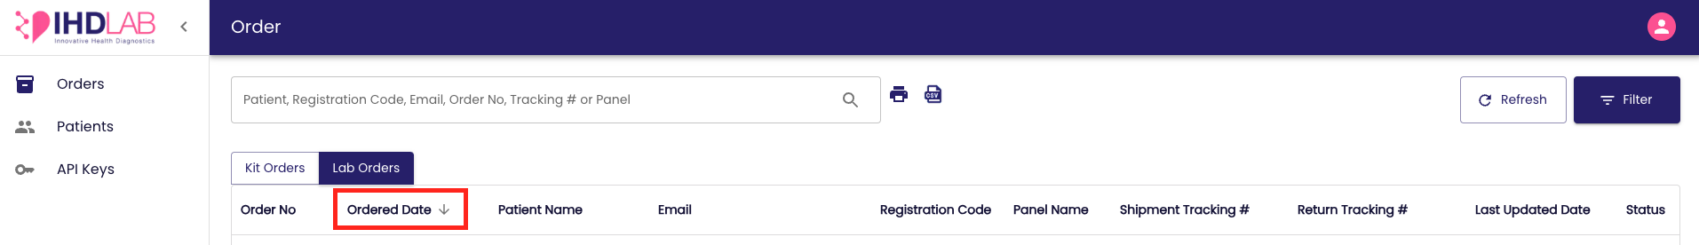

  - Filter- Locate the Filter option on the top right corner of the dashboard.

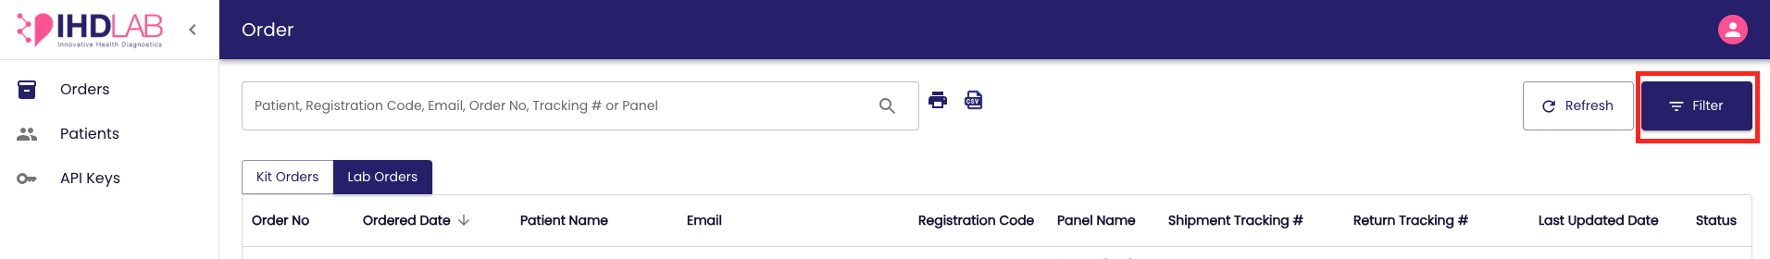

On-click the filter panel will be prompted and you can select the filter criteria from the option. Upon selection, click on the ‘Apply’ button and the dashboard will update to show entries that match the chosen criteria. To clear filters, click on the ‘Clear Filters’ button, and to set the default filter selection, click on the ‘Set Default’ button.

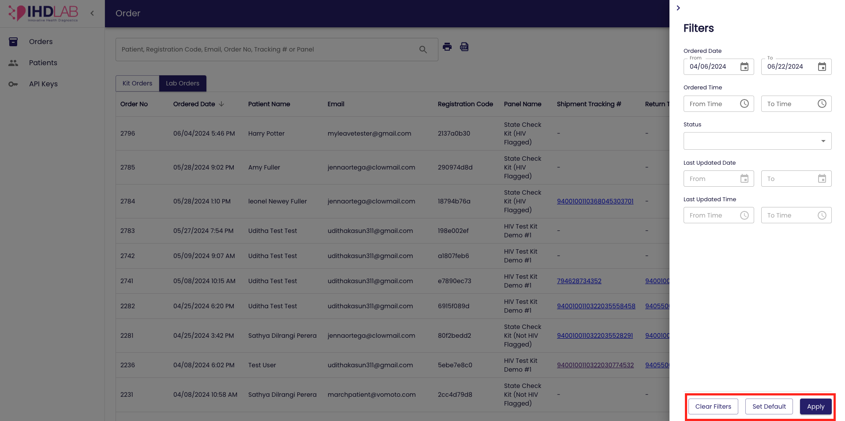

  - Print- Locate the Print icon next to the search bar. Ensure the dashboard is displaying the data you want to print. You can use search, sort, and filter options to refine the displayed entries as needed. Click on the ‘Print’ icon.

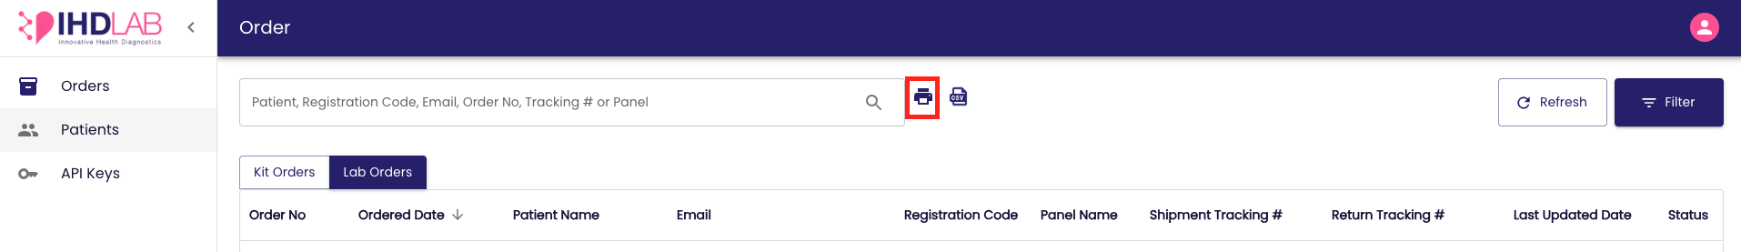

A print preview window will open, displaying the formatted data ready for printing. Click ‘Print’ in the preview window to send the document to your printer.

  - Export CSV- Locate the CSV icon next to the print icon. Ensure the dashboard is displaying the data you want to export. Use search, sort, and filter options to refine the entries as needed. Click on the ‘Export CSV’ icon and the CSV file will be downloaded.

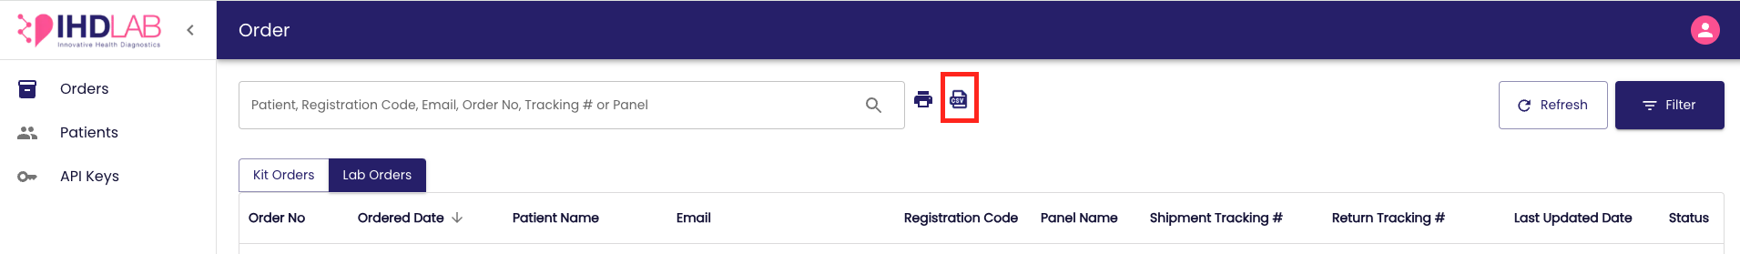

  - Refresh- Locate the Refresh button next to the Filter button in the top right corner. Click on the ‘Refresh’ button. The dashboard will reload, fetching the latest data. You may see a brief loading indicator while the data is being refreshed.
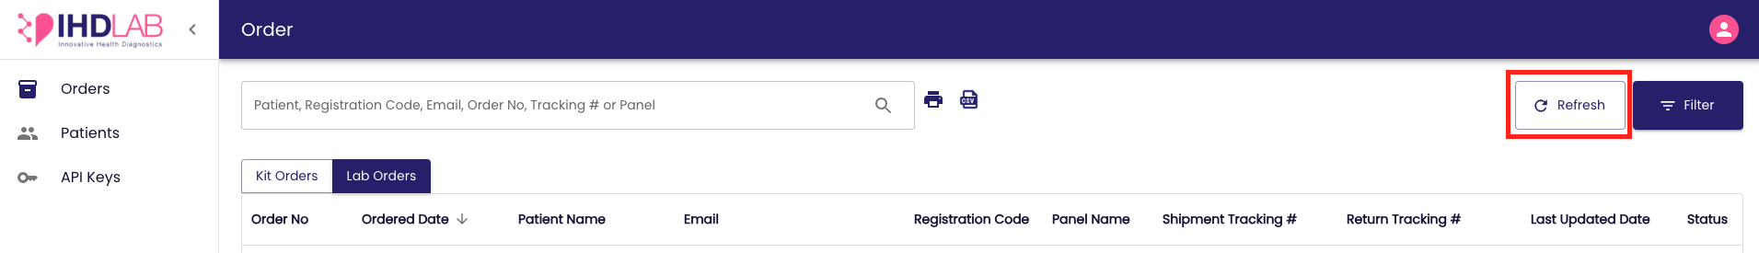

- You can view the order detail page by clicking on the entry. This can be done by clicking anywhere on the entry row. Identify the entry you want to view in detail. Click on the Order entry. You will be redirected to the ‘Order Detail’ Page of the selected entry.

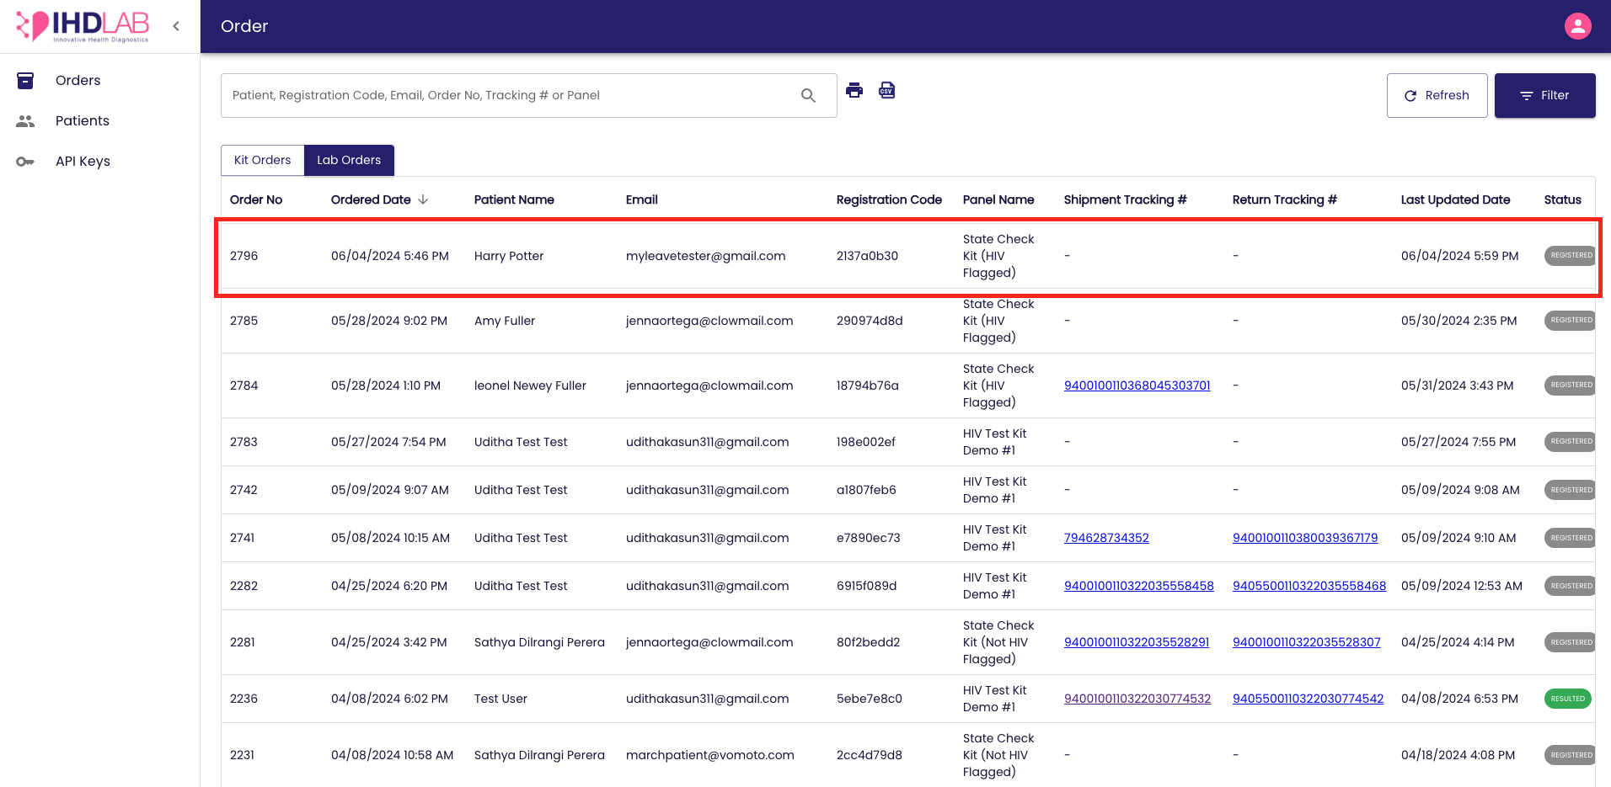

The Detail Page will provide comprehensive information about:
- Lab Order
- Patient Details
- Patient Address

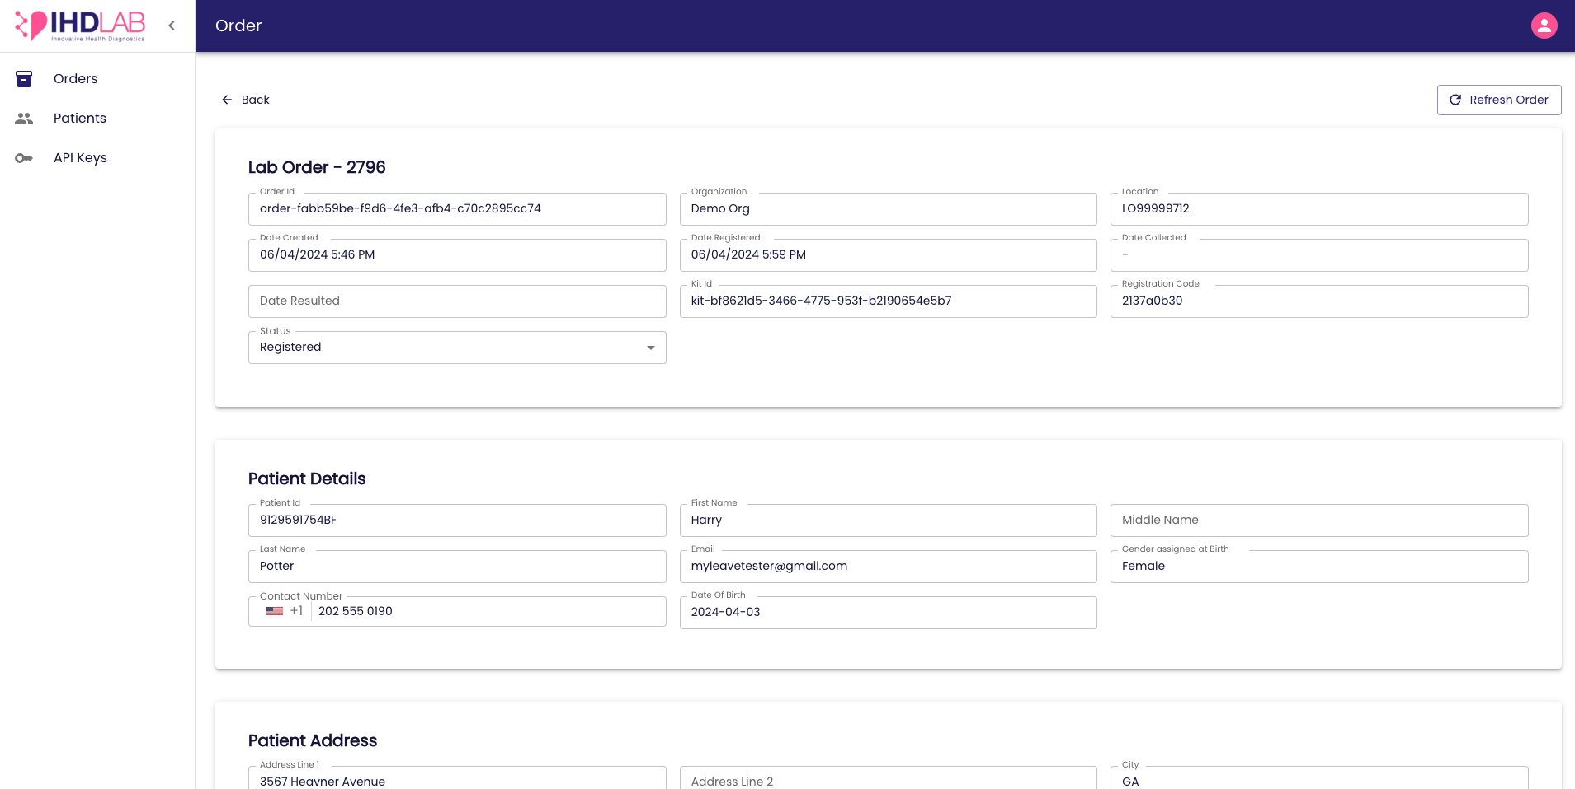

You can click on the ‘Refresh Order’ button on the top-right corner of the Order detail page to fetch the latest data. You may see a brief loading indicator while the data is being refreshed.

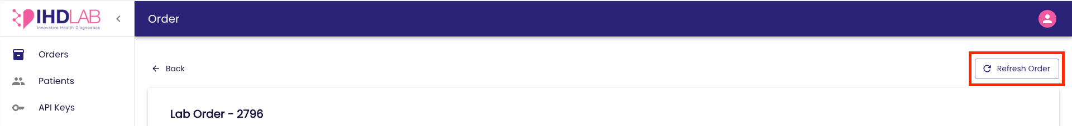

You can click the ‘Back’ button on the top-left corner of the Order detail page to go back to the ‘Order’ dashboard.

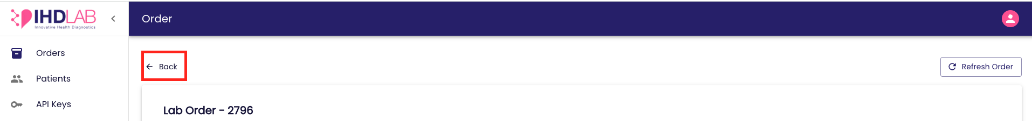

Patients Dashboard
- All the patients registered in the Labflow platform from your organization will be displayed in the ‘Patient’ dashboard.
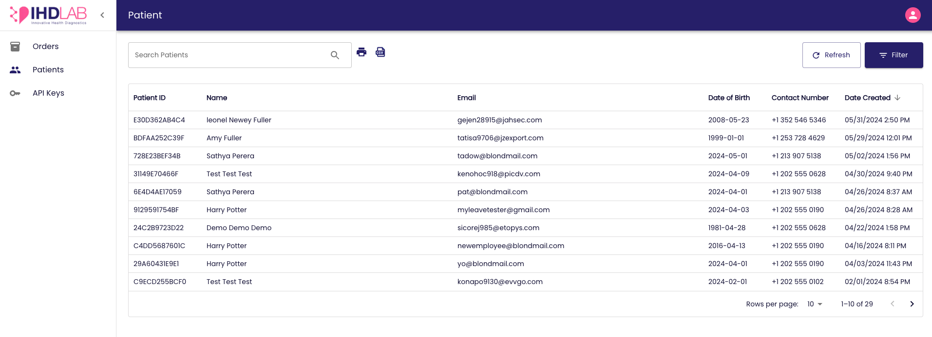

- The following patient details will be available:
  - Patient ID
  - Patient Name
  - Email
  - Date of Birth
  - Contact Number
  - Date Created

- You can use the following features to interact with the dashboard:
- Search- Locate the search bar on top of the dashboard. Click inside the search bar and type in the keyword or phrase you want to search for. You can search by the Patient ID, Name, and Email. Press Enter or click the Search icon. The dashboard will update to display entries that match your search criteria.

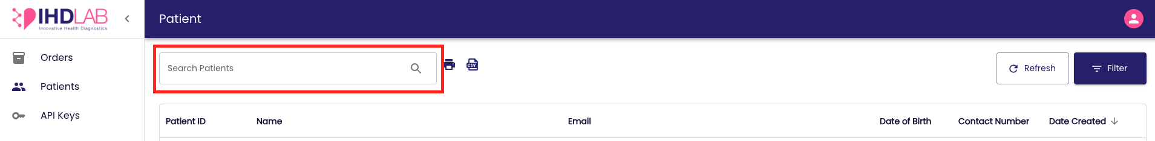

- Sort- Find the Sort options in the table header represented by an arrow. Click on the column header you wish to sort by and on-click it will sort in ascending order, and clicking again will sort in descending order.

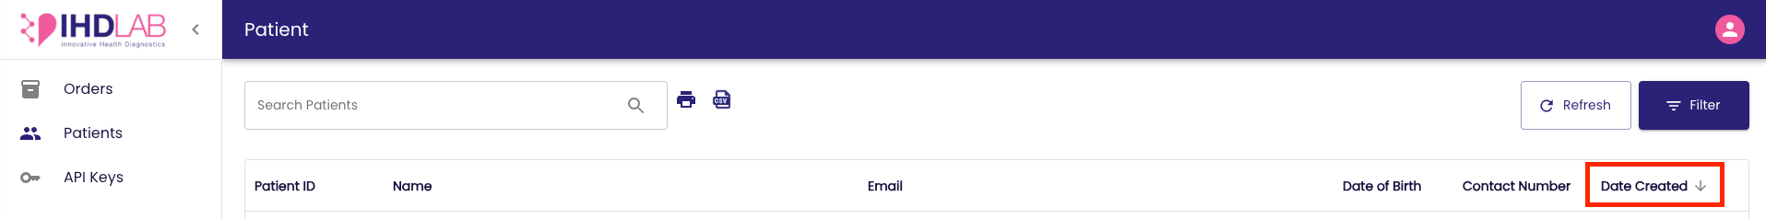

- Filter- Locate the Filter option on the top right corner of the dashboard.

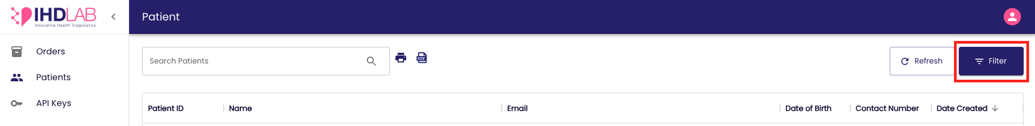

On-click the filter panel will be prompted and you can select the filter criteria from the option. Upon selection, click on the ‘Apply’ button and the dashboard will update to show entries that match the chosen criteria. To reset filters, click on the ‘Reset’ button.

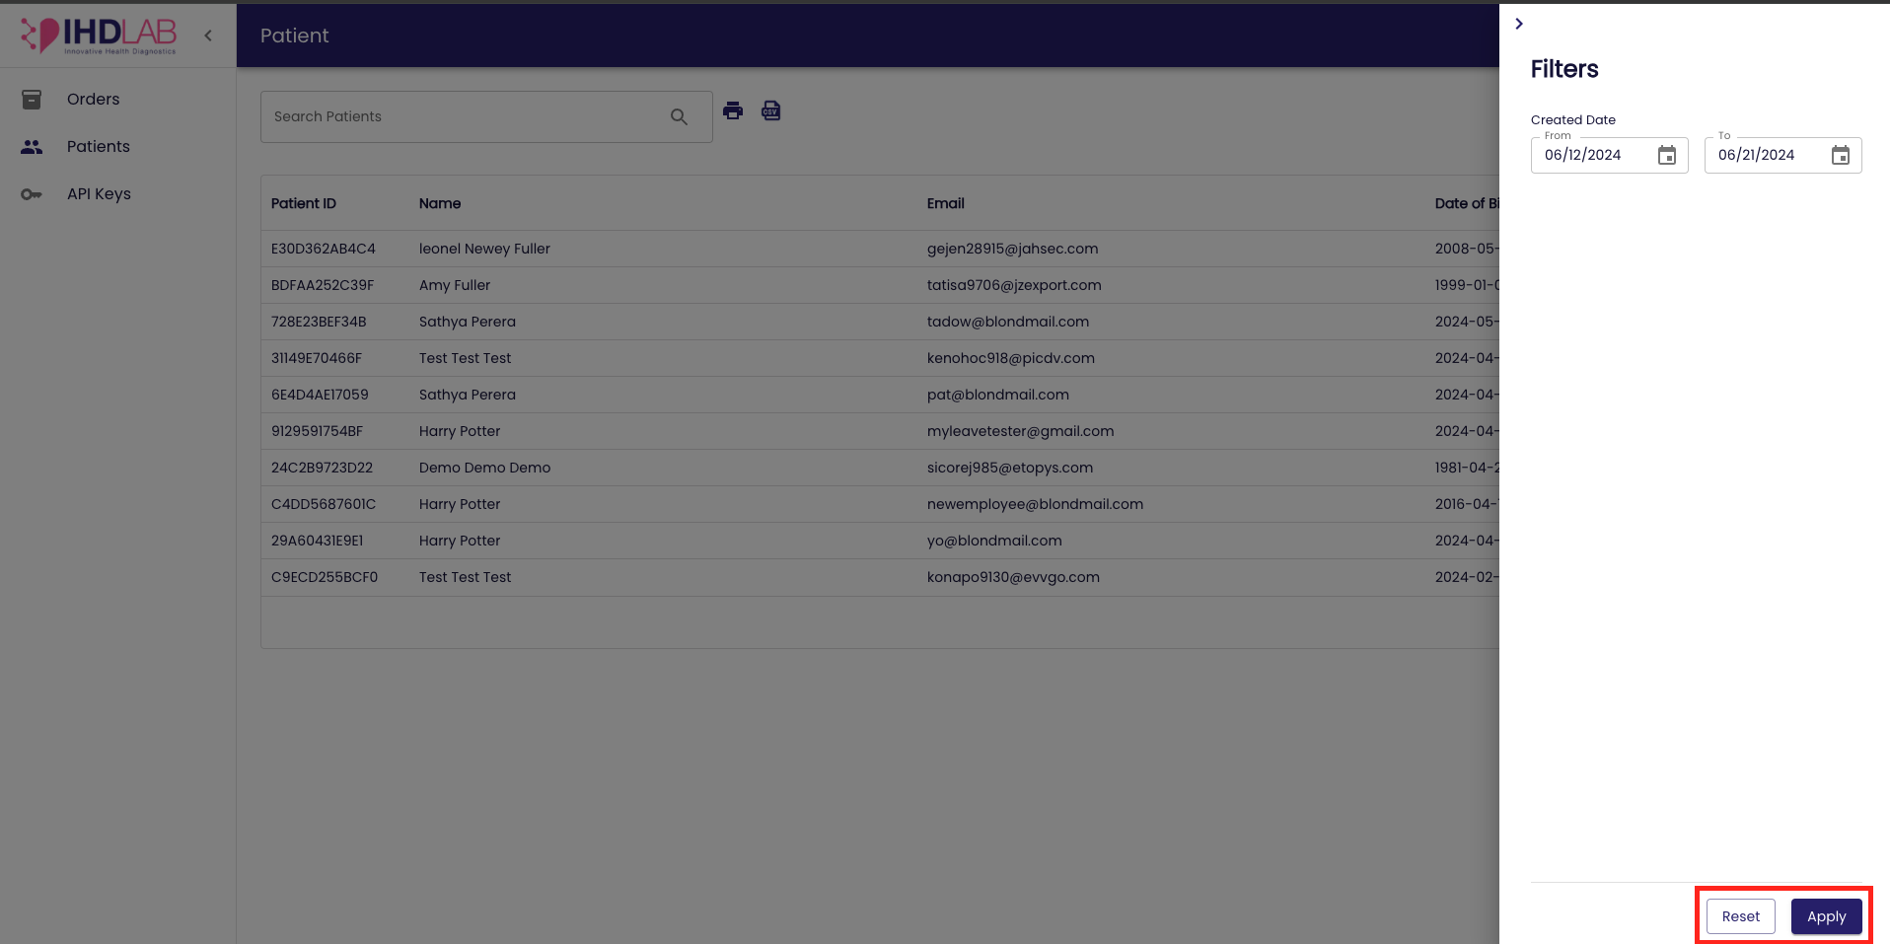

- Print- Locate the Print icon next to the search bar. Ensure the dashboard is displaying the data you want to print. You can use search, sort, and filter options to refine the displayed entries as needed. Click on the ‘Print’ icon.

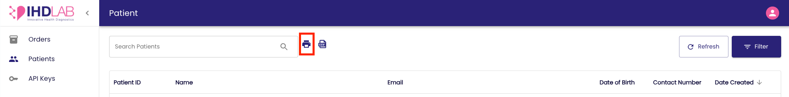

A print preview window will open, displaying the formatted data ready for printing. Click ‘Print’ in the preview window to send the document to your printer.

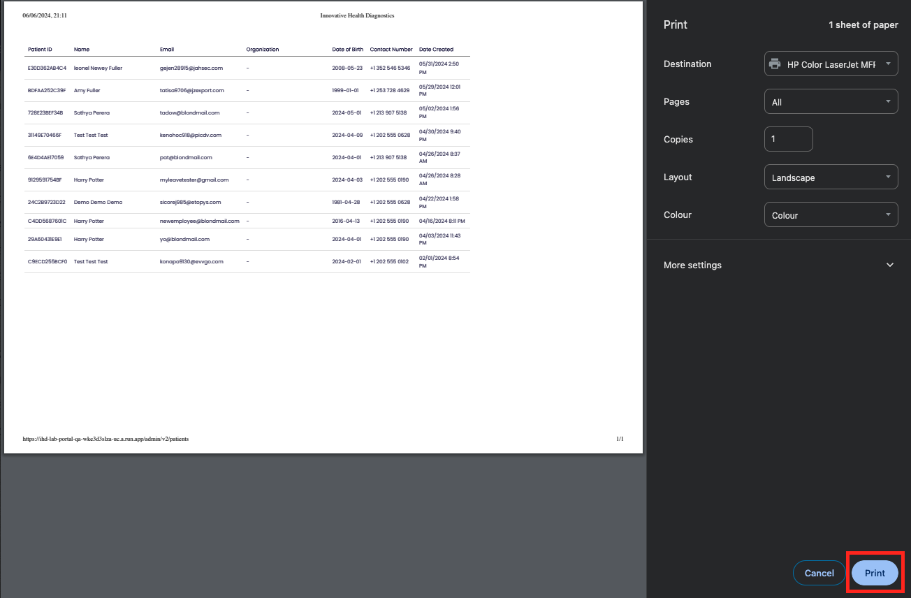

- Export CSV- Locate the CSV icon next to the print icon. Ensure the dashboard is displaying the data you want to export. Use search, sort, and filter options to refine the entries as needed. Click on the ‘Export CSV’ icon and the CSV file will be downloaded.

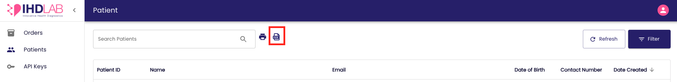

- Refresh- Locate the Refresh button next to the Filter button in the top right corner. Click on the ‘Refresh’ button. The dashboard will reload, fetching the latest data. You may see a brief loading indicator while the data is being refreshed.

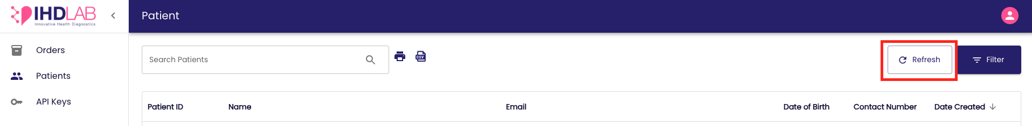

- You can view the patient detail page by clicking on the entry. This can be done by clicking anywhere on the entry row. Identify the entry you want to view in detail. Click on the Patient entry. You will be redirected to the ‘Patient Detail’ Page of the selected entry.

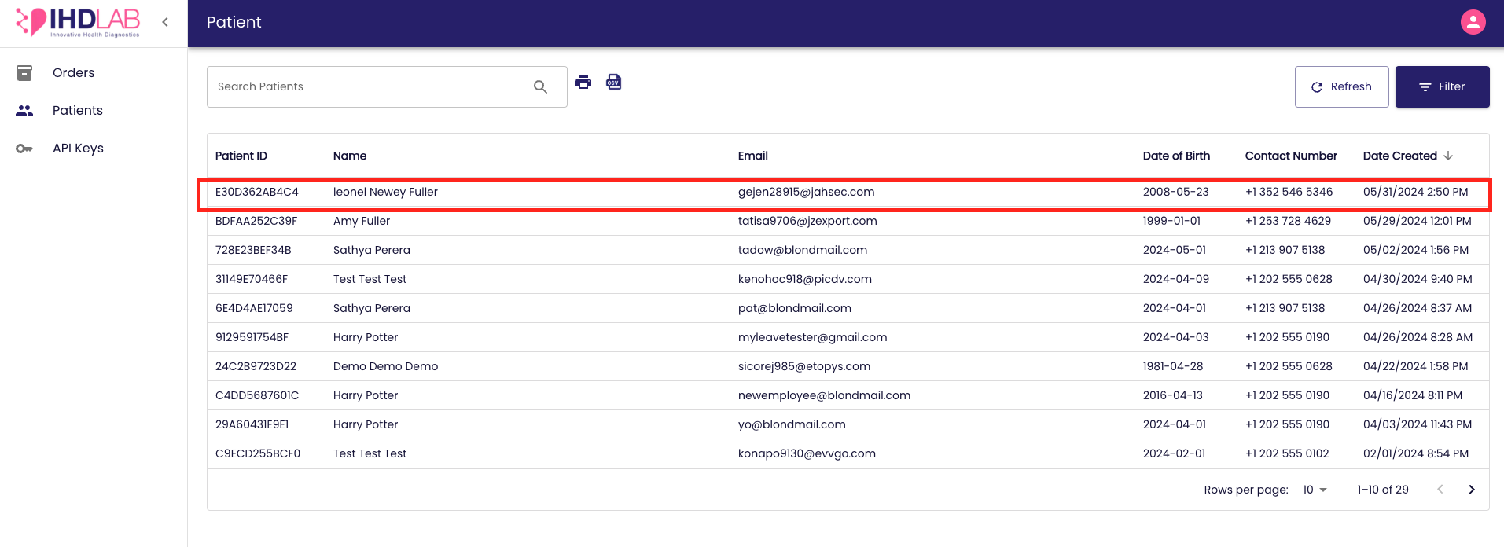

The Detail Page will provide comprehensive information about:
- Customer Details
- Mailing Details
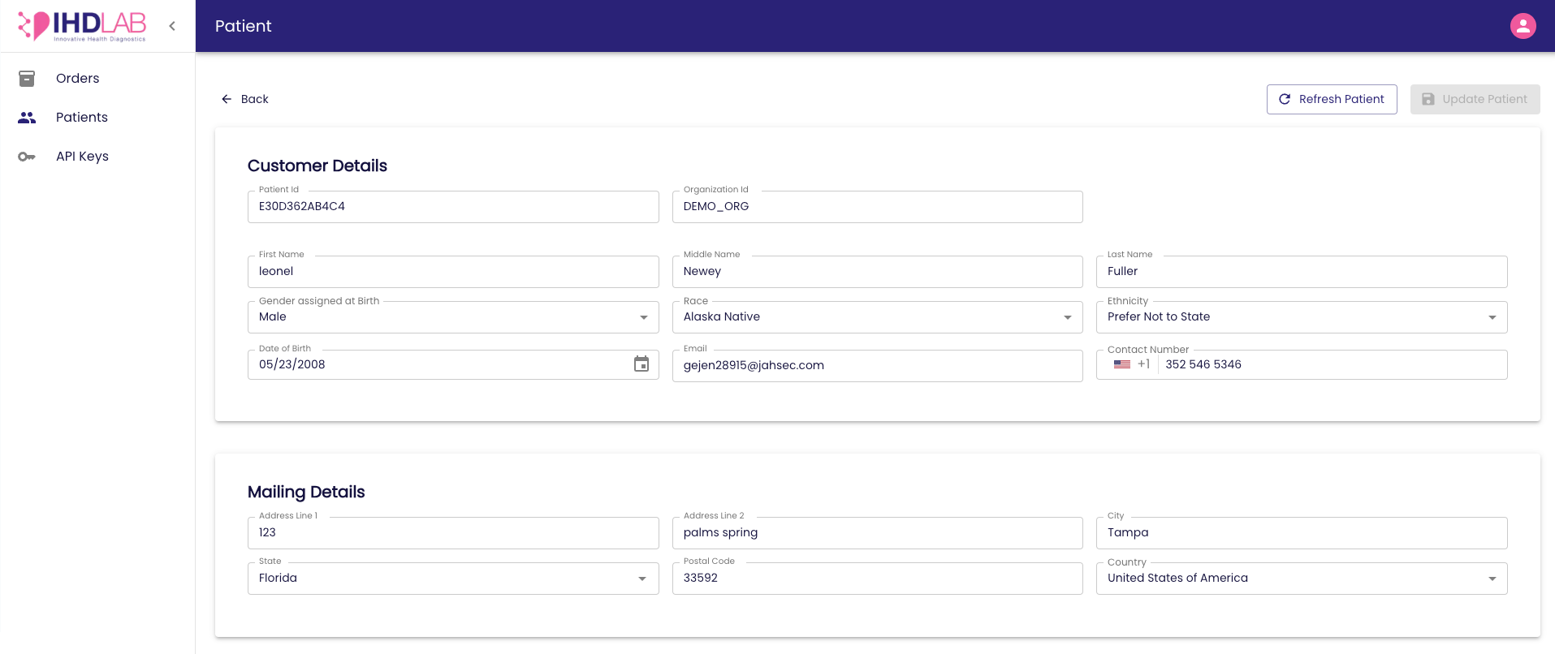
You can edit the following fields:
- Gender
- Race
- Ethnicity
- Contact number
- Mailing Details

On-click of the field, the edit view will be enabled and once edited the ‘Update Patient’ button on the top-right corner of the patient detail page will be enabled. You can click on the button and save the details. A success message will be prompted.

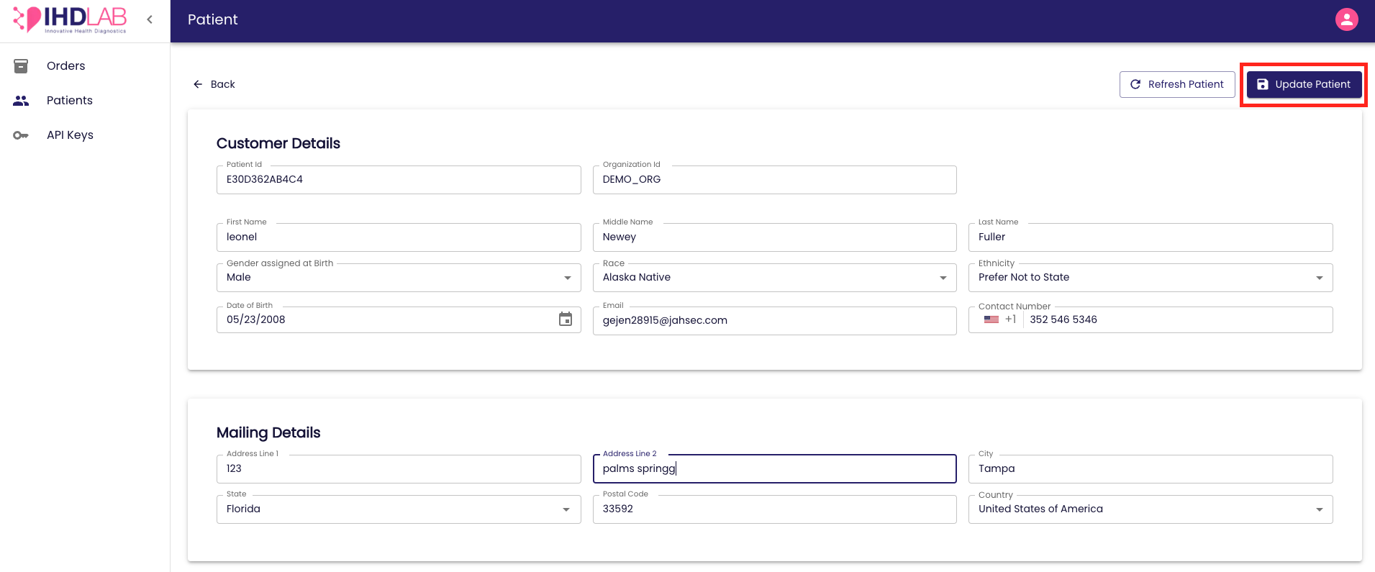

You can click on the ‘Refresh Patient’ button on the top-right corner of the patient detail page to fetch the latest data. You may see a brief loading indicator while the data is being refreshed.

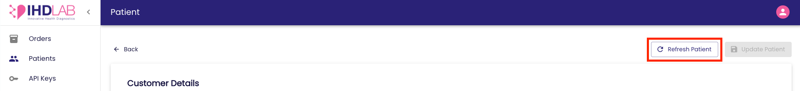

You can click the ‘Back’ button on the top-left corner of the Patient detail page to go back to the ‘Patient’ dashboard.
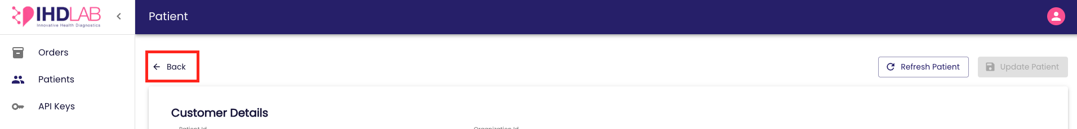

API Keys Dashboard
- All the API Keys created for your organization will be displayed in the ‘API Keys’ dashboard.

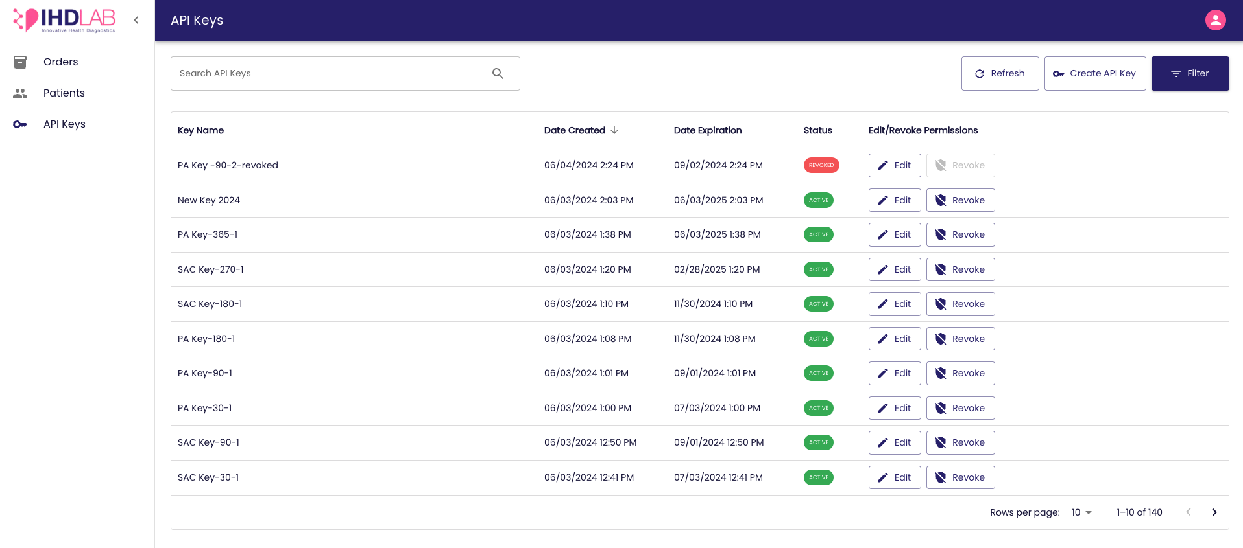

- The following API Key details will be available:
- Key Name
- Date Created
- Date Expiration
- Status
- Edit/ Revoke Permissions

- You can use the following features to interact with the dashboard:
- Search- Locate the search bar on top of the dashboard. Click inside the search bar and type in the keyword or phrase you want to search for. You can search by the Key name. Press Enter or click the Search icon. The dashboard will update to display entries that match your search criteria.

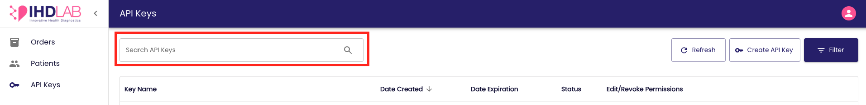

- Sort- Find the Sort options in the table header represented by an arrow. Click on the column header you wish to sort by and on-click it will sort in ascending order, and clicking again will sort in descending order.

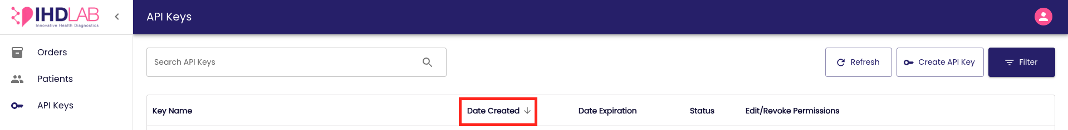

- Filter- Locate the Filter option on the top right corner of the dashboard.

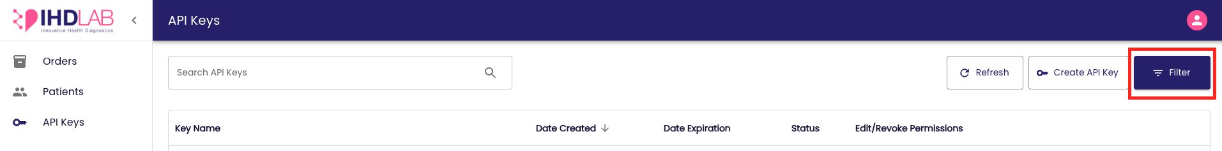

On-click the filter panel will be prompted and you can select the filter criteria from the option. Upon selection, click on the ‘Apply’ button and the dashboard will update to show entries that match the chosen criteria. To reset filters, click on the ‘Reset’ button.
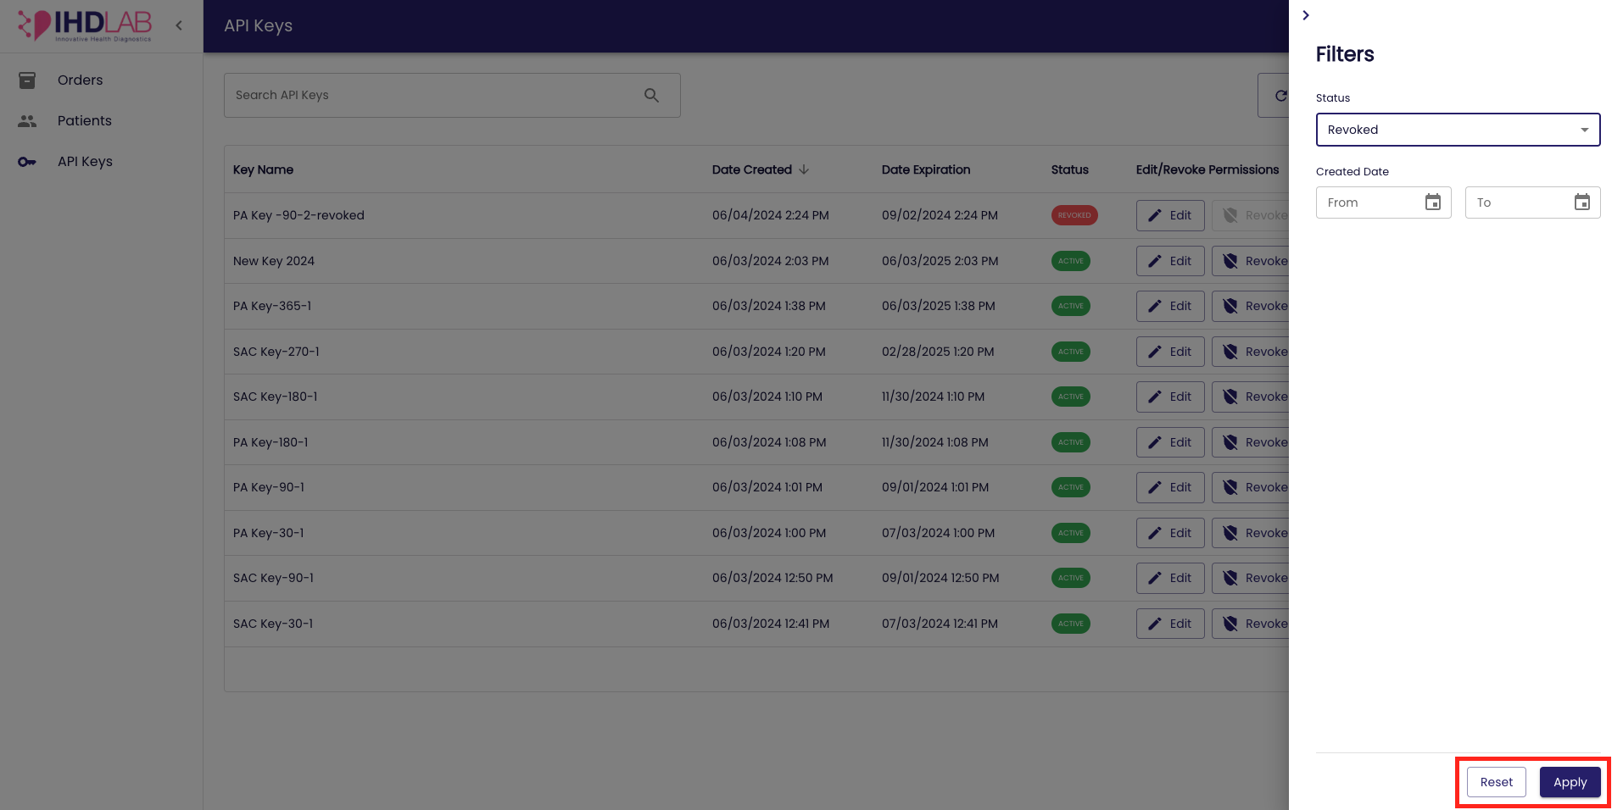

- Refresh- Locate the Refresh button next to the Filter button in the top right corner. Click on the ‘Refresh’ button. The dashboard will reload, fetching the latest data. You may see a brief loading indicator while the data is being refreshed.

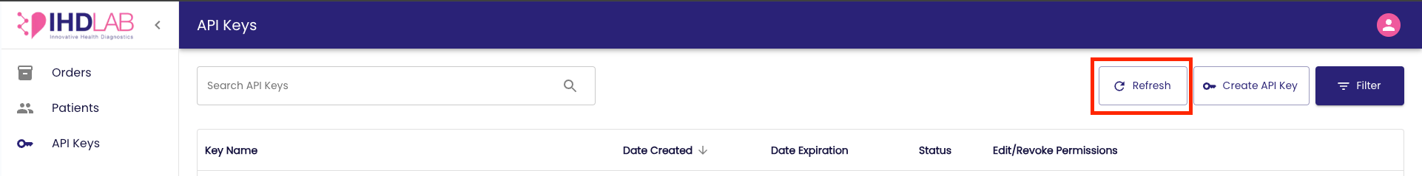

Create API Key
- You can create a new API key by clicking on the ‘Create API Key’ button.

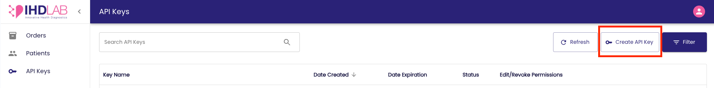

- Enter the following details:
  - API Key Name- Enter a relevant API key name
  - Expiration time- Select the expiration time from the list

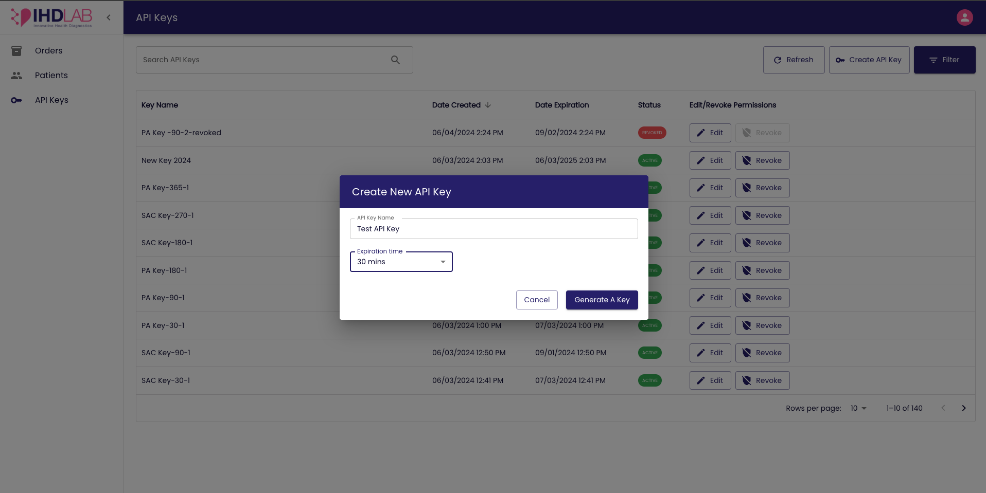

- Click ‘Generate Key’ to create a new API key and upon successful key creation the new key will be prompted on the screen. You can copy the key by clicking on the ‘Copy’ icon.

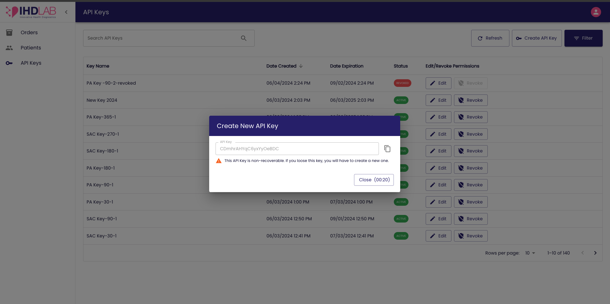

- The new key along with the details will be displayed as a new entry in the dashboard.

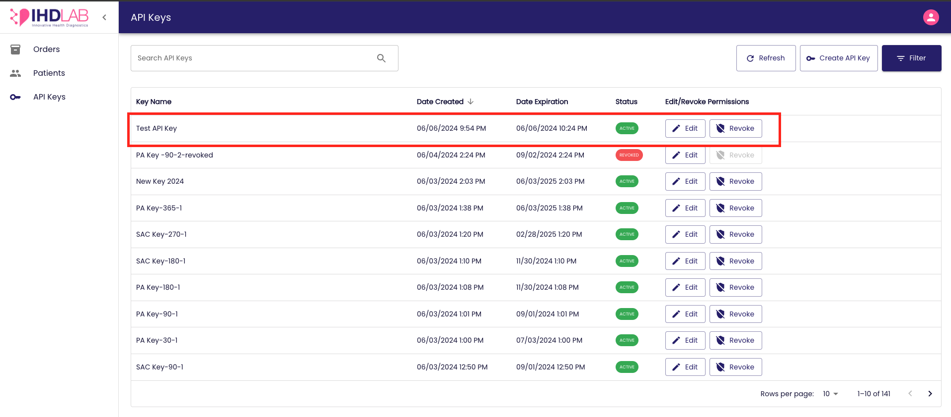

Edit/ Revoke API Key Permissions
- You can edit/ revoke the API key permission from the dashboard. The options are available in the dashboard entry.

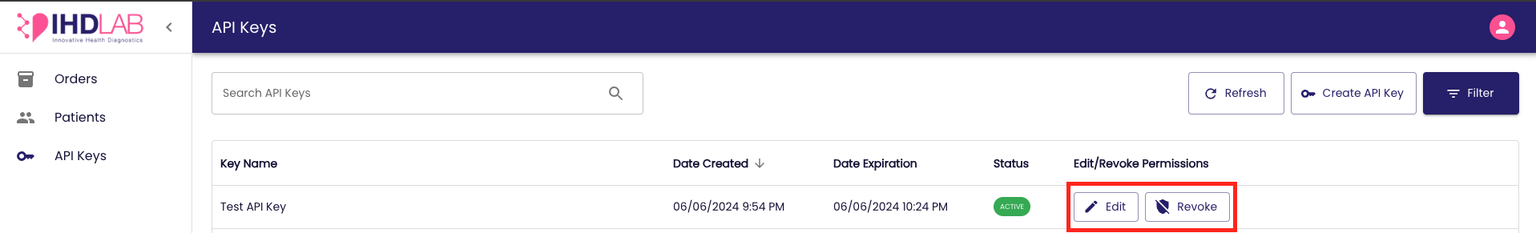

- If you want to edit the key details, click on the ‘Edit’ button and the ‘Edit’ pop-up will be prompted. You can update the key name and click on the ‘Save’ button to save the changes and a success message will be displayed.
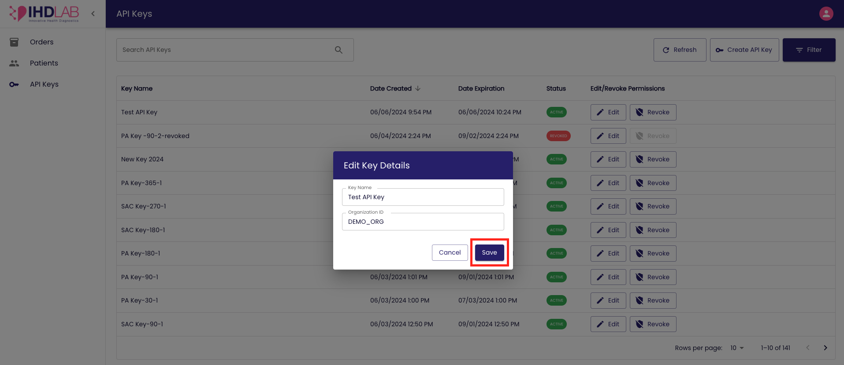

- If you want to revoke the key, click on the ‘Revoke’ and the ‘Revoke key’ pop-up will be prompted. Click on the ‘Yes’ button to proceed and a success message will be displayed.

